DOM (lecture 31)(Document Object Model introduction in js)

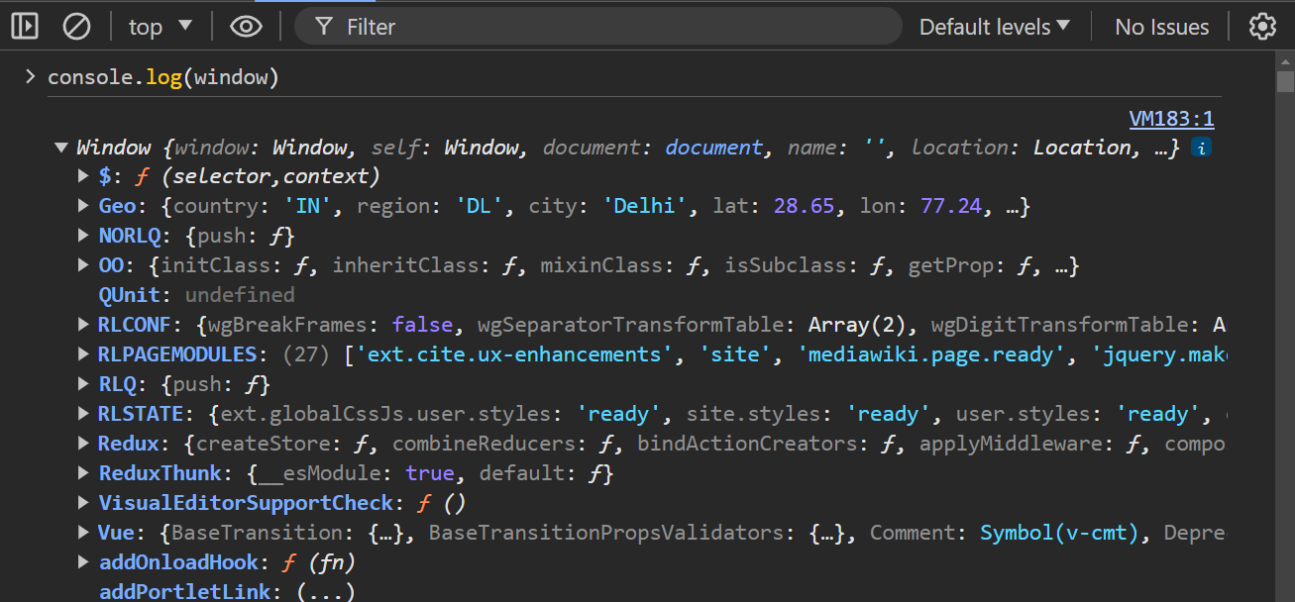

Press console.log(window) to see the window object. Here you will see many elements and functions but humara main kaam document se hoga

_________________________________________________________________________________

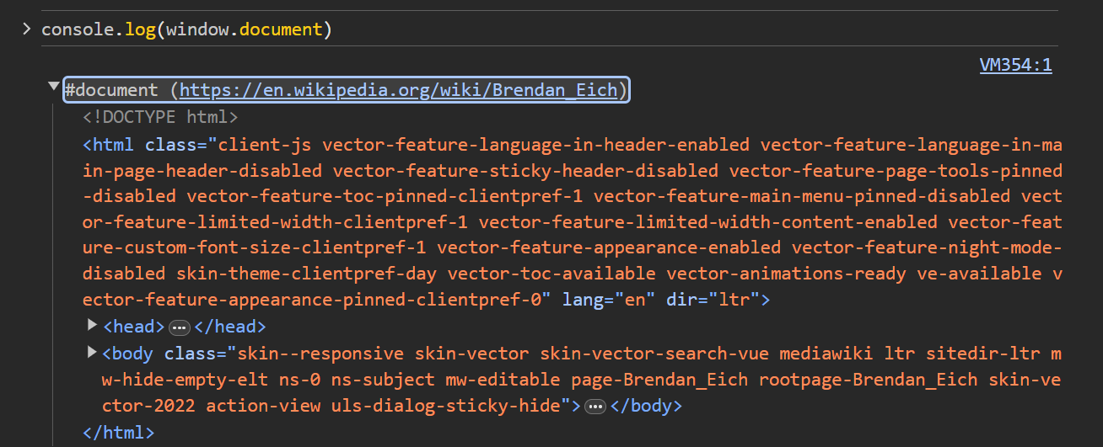

As window is an object we can access our document properties using above statement.

Can also write only console.log(document) will get same. But in case you want more information write console.dir(document) will get hidden info( very rare use).

_________________________________________________________________________________

Below will see a short diagram of document ( imp for interview)

Visualise parent child relationship ( like head and body are the children of HTML tag



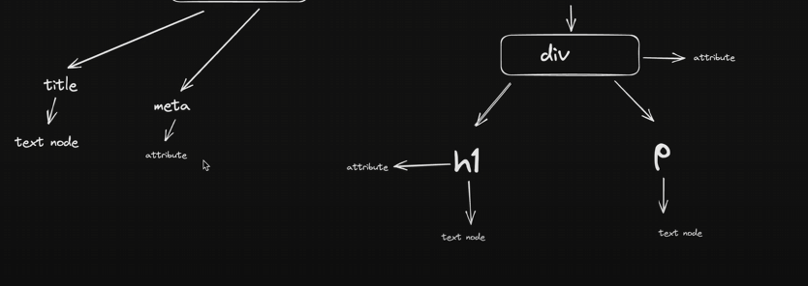

This web diagram should be clear in mind while accessing and manipulating elements of web page.

Text node is simply text written under tag visible on web page( diagram made for one.html under dom before list element )

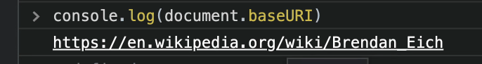

Will give clean url of webpage

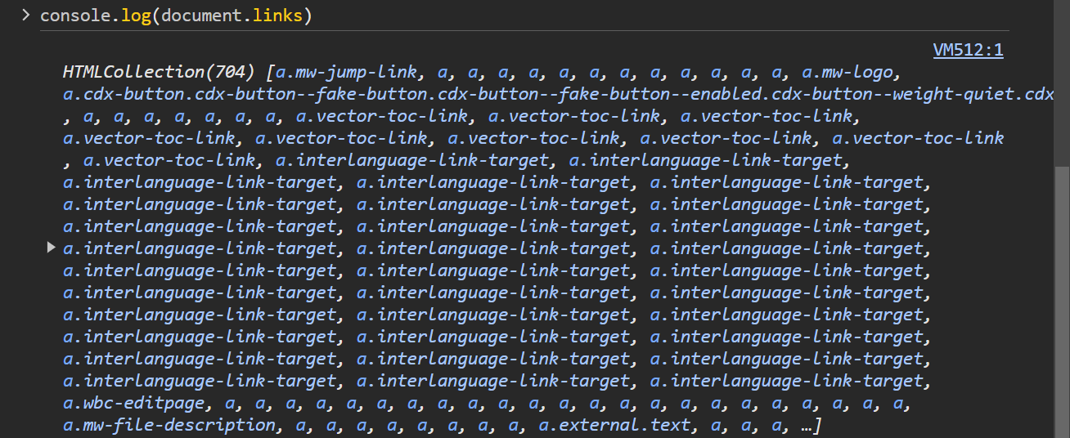

Above statement gave all links present in the web page but in a html collection and not in an array. They are not pure arrays. Note that html collection, nodelist and array are not exactly same. Html collection and nodelist are like arrays but don’t possess all functions of arrays. These can be converted into arrays and now all functionalities of arrays can be implemented onto them.

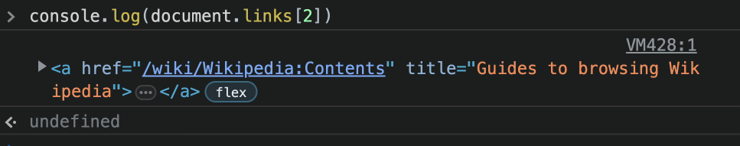

But html collection mei bhi indexing k through elements can be accessed like arrays.

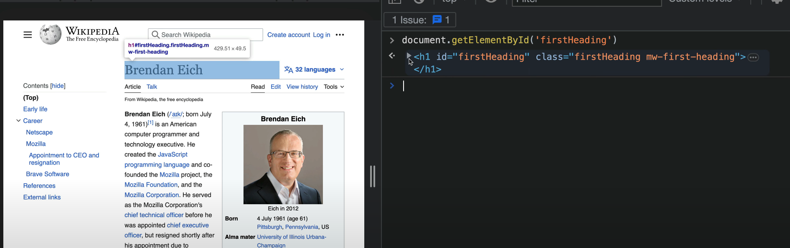

Now will be learning how to select elements.like above

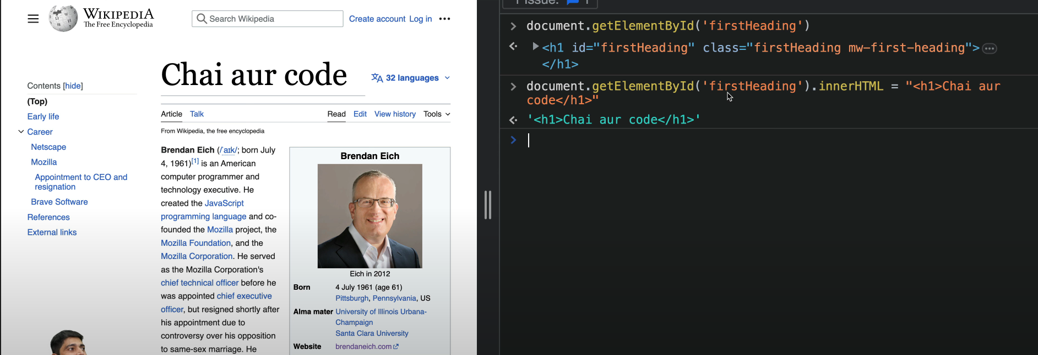

Manipulated web page by dom

Lecture 32 (refer one.html of dom)

All DOM selectors NodeList and HTMLCollection

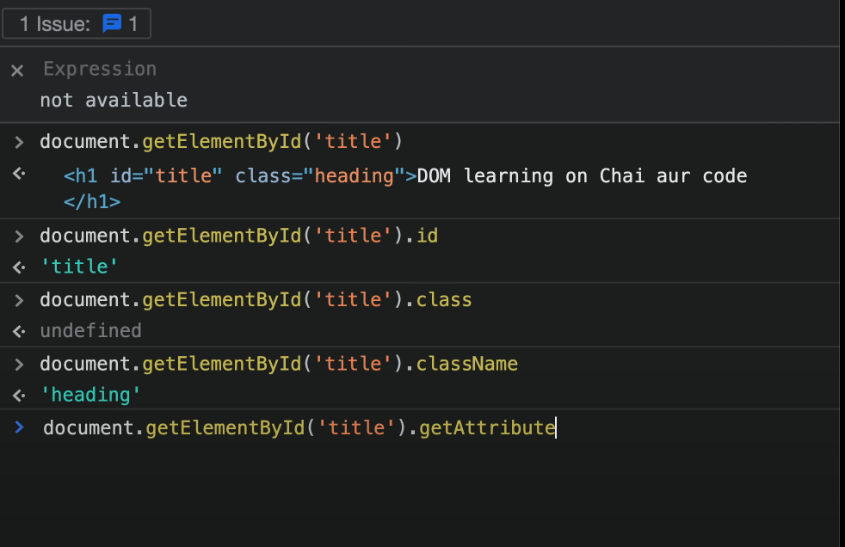

Class nahi use className as backend mei className se store hota hai

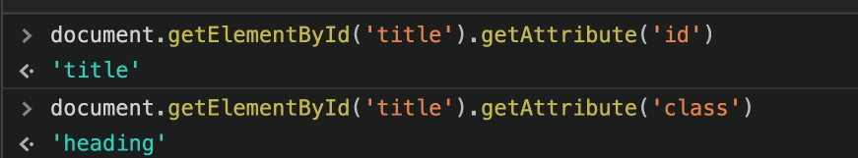

Here enter attribute as key and you will get value

We can also set the value of attributes (overwrite them) as below

First select item jispe operation lagana ho then apply operation

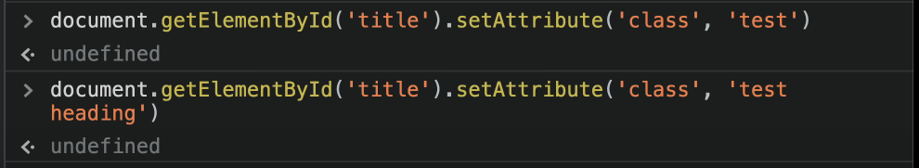

We can also store our selected element or object under a variable for easy access as shown below

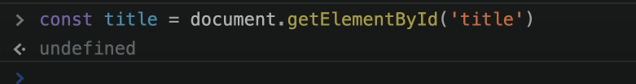

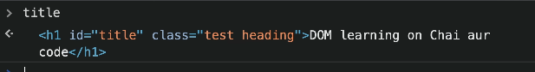

Can also add styling to our selected object as follows

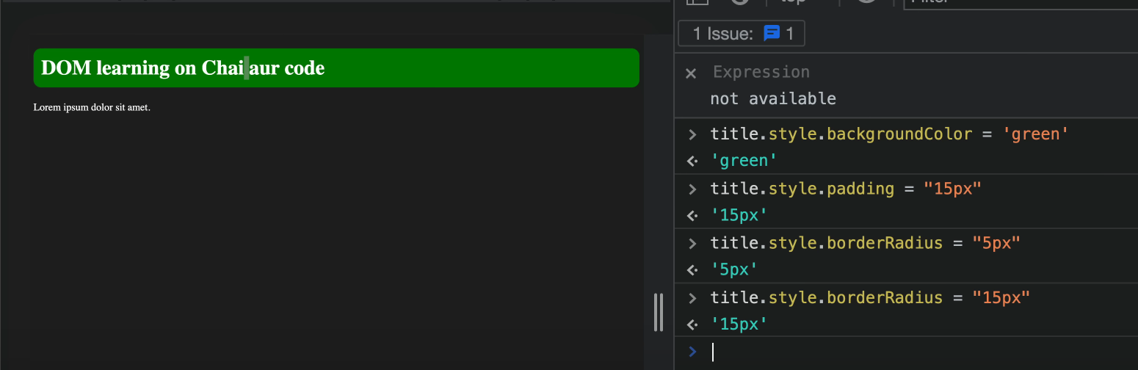

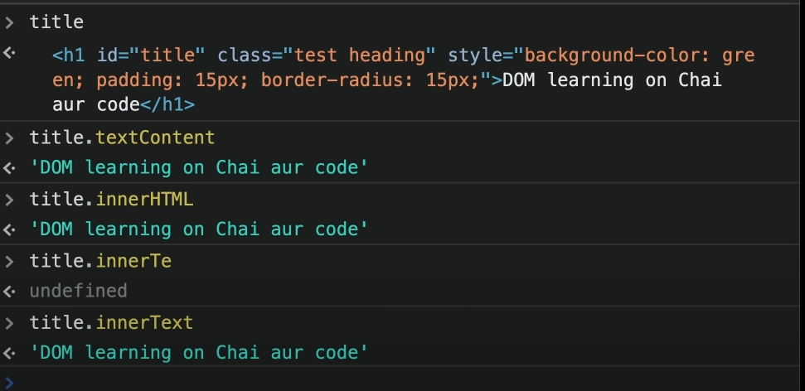

Above observe we want to extract content now stored in our object. But textcontent, innerHTML and innerText teeno are giving same value so whats the difference?

Ans. First will understand the differencve between innerText and textcontent:



This change we made (basically test text ko css property lagake hide kar diya page pe only chai aur code is visible)

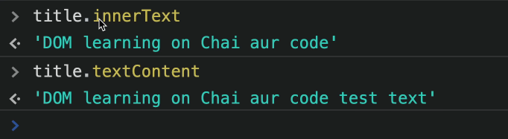

Observe innertext pe only that content visible jo webpage pe show ho rha hai.

Textcontent pe lekin saara content display hoga no matter how much and what type of css you have used.

Now both are good depends upon the use case.

If you want jo screen pe dikh rha khaali uske hisab se visual changes I have to make then use innertext and if you want ki sara display ho then use textcontent.

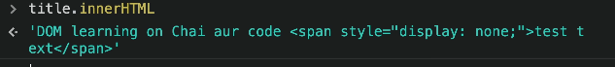

InnerHTML basically text node k saath saath uske andar ka html tags bhi show karta hai.

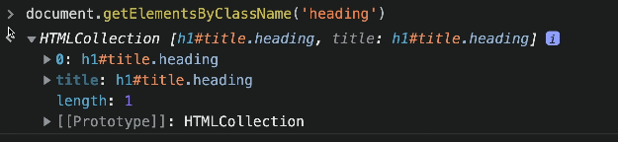

Now neeche wale selectors will be used in most of the times

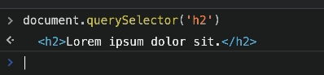

Isme bracket mei give tag name you will get first item of webpage with that tag. Basically webpage pe kahi sare elements could exist with h2 tag.

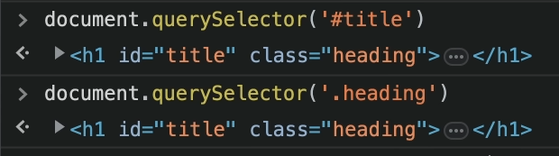

Can also pass ids and classes in css format (# and .) to select element.

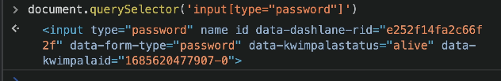

Another example of selecting using css properties above.



Depends upon the kitna css selectors padha hai

Now we can use queryselector in nested way too as below explained in example

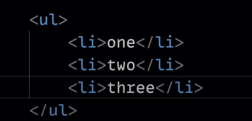

Suppose you want to change the color of first list item to green. How would you select it and perform the desired operation?

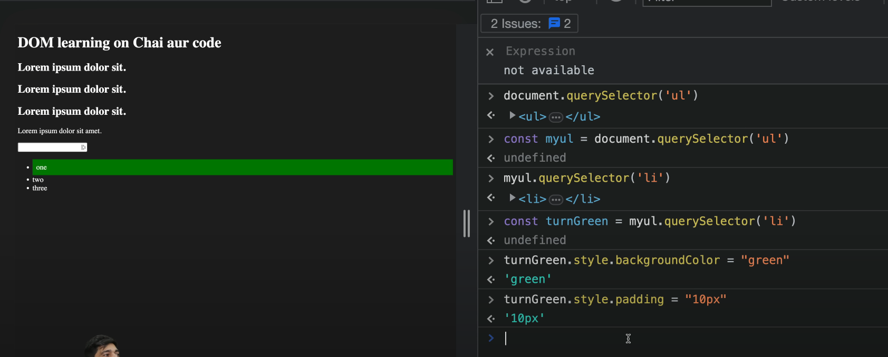

Below we changed innertext from one to five

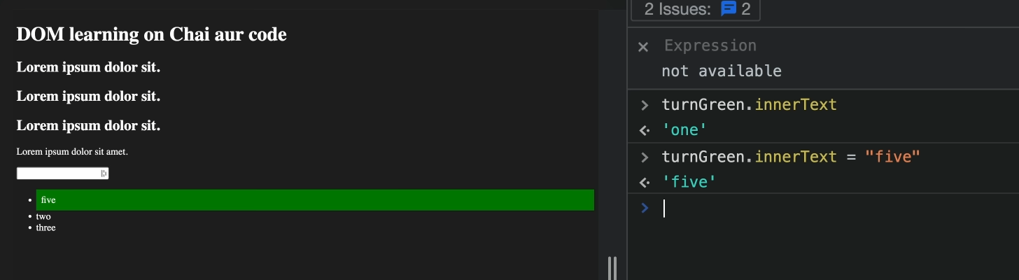

But if you want to select all list elements ( or if you want to select all elements of same tag use below queryselector)

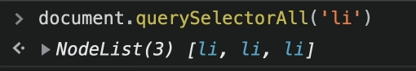

Now note that above query gave a nodelist in return not an array. As in an array it has all methods like map() in its prototype but isme nahi hai.

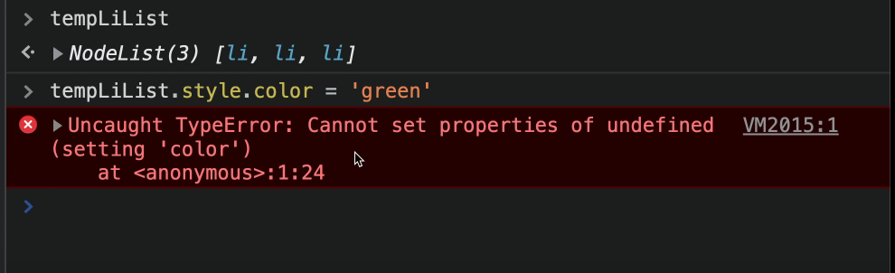

Here if we tried to change color of all at a time then nahi ho paayega as different syntax. Though it is not a pure array but still it Is array like and we can still use some array properties here.

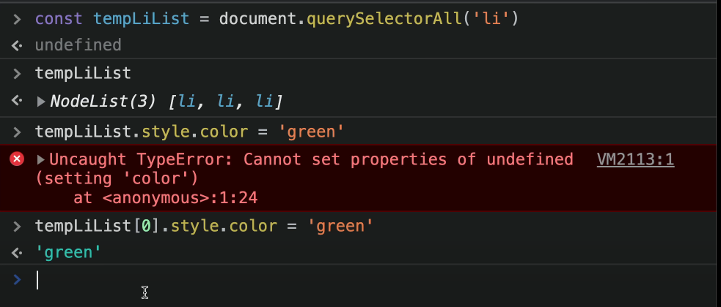

So basic difference between queryselector and queryslectorall is all on return type. Queryselectorall returns nodelist whereas queryselector returns directly the element.

Now assume we are getting a single element in nodelist as below.

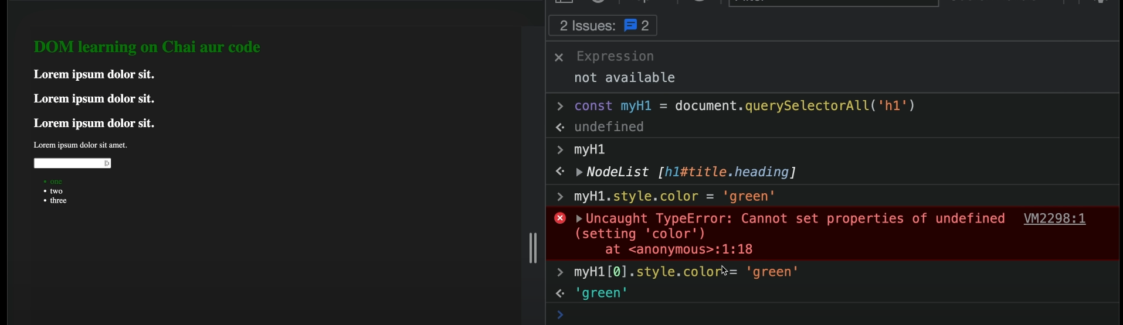

So basic syntax to array jesa hi follow karna padega no matter how many elements are there in nodelist.

But nodelist provides us the functionality of foreach loop so we can use it for coloring all elements of list.

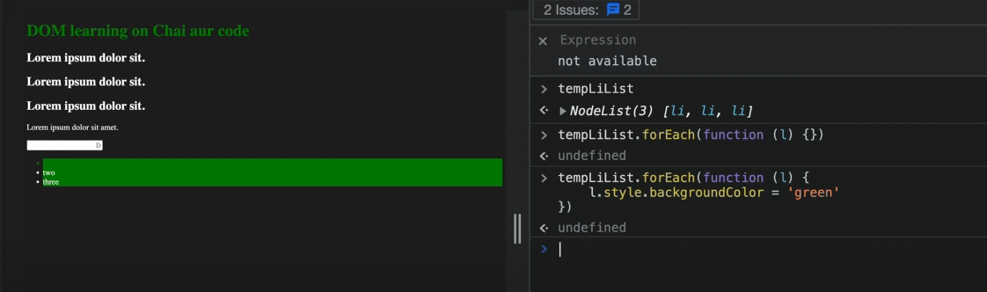

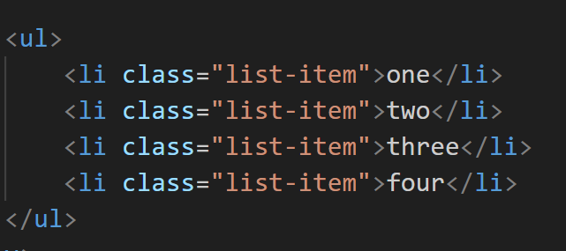

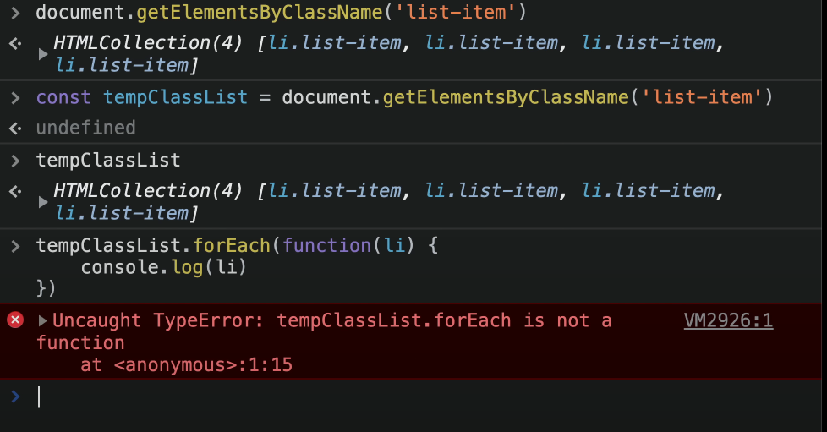

Now above queryselector returns HTML collection jisme na map() hain a foreach function so for iterating it have to convert it into an array first as below.

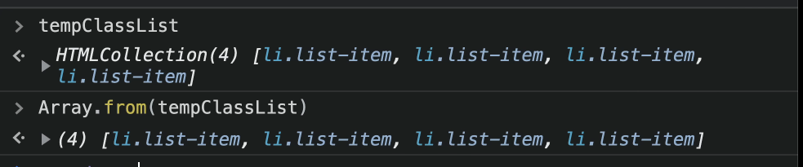

Now can use all functionalities of array like foreach() map() etc.

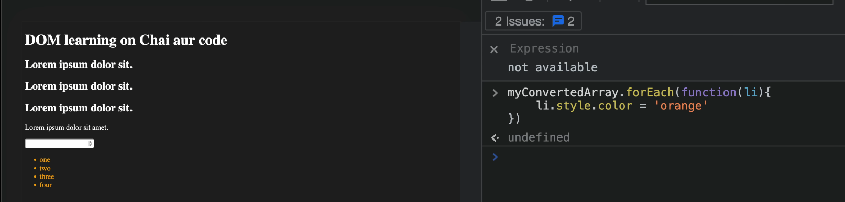

Lecture 33

How to create a new element in DOM (refer two.html under 06_dom)

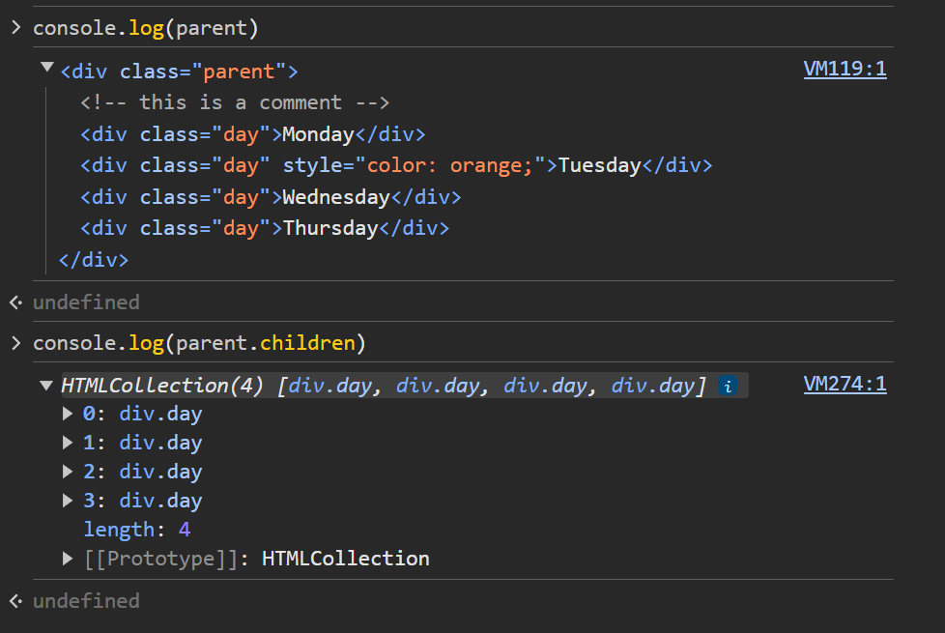

Here note above we get html collection.

Though we cant apply foreach loop here but accessing of elements will be done with indexing only as arrays

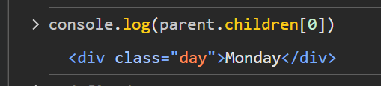

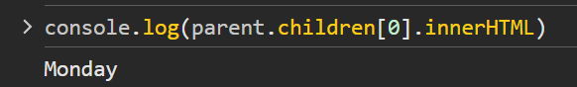

Now we don’t have any foreach for html collection but normal for loop to har jagah general hota hai

See below

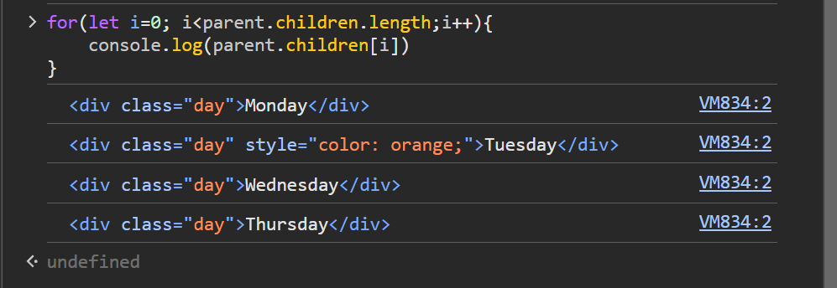

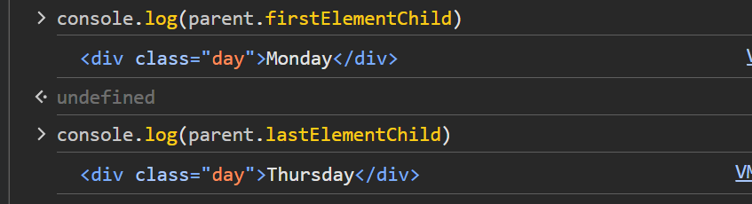

Above see two methods to directly access first and last element of html collection

---------------------------------------------------------------------------------------------------------------------------------

Above we were trying to move from parent to child. Now in below examples we will try to reach parent element if child is available to us.

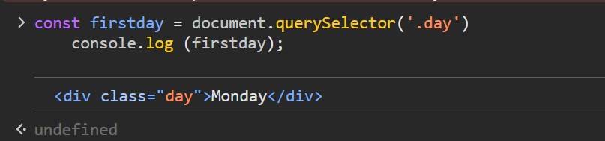

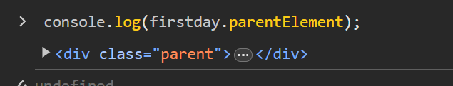

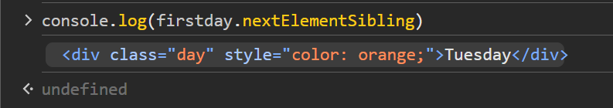

Above method for checking sibling

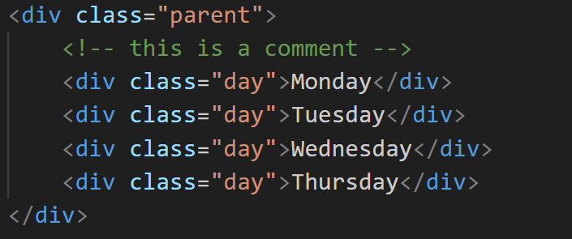

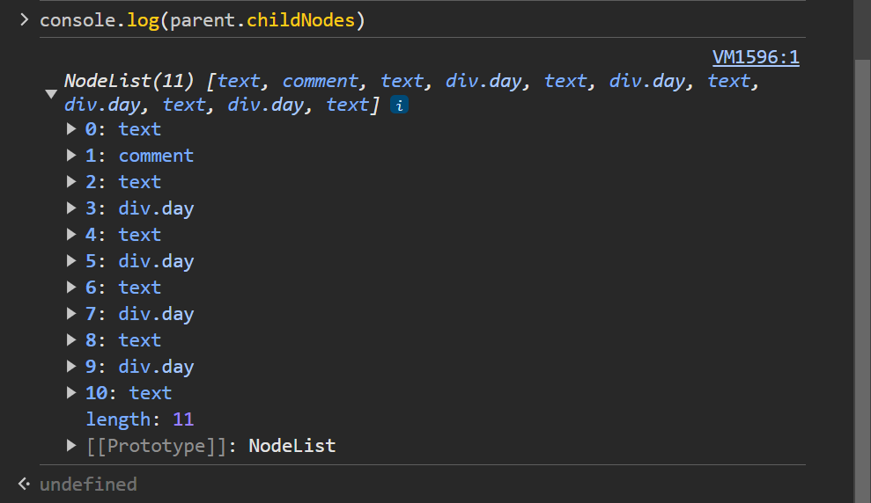

Above method gives nodelist as return element. Note here childnodes does not came as Monday Tuesday as line breaks (enter) bhi are treated as text nodes.(thoda complex structure)

Iske aage refer three.html under dom

Dom notes finished